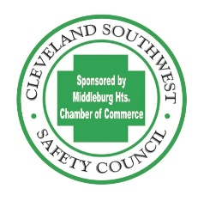
CLEVELAND SOUTHWEST SAFETY COUNCIL

(Sponsored by the Middleburg Hts. Chamber Commerce)

OHIO SAFETY COUNCIL

2024-2025 ENROLLMENT FORM
Email: clesouthwestsafety@gmail.com Phone: (216) 496-0126

BWC’s Division of Safety & Hygiene co-sponsors safety councils to provide Ohio employers with access to occupational safety and health, workers’ compensation and risk management education, networking, and resource sharing. In completing this enrollment form, the employer makes a commitment to send representatives to monthly safety council meetings.

Enrollment date Deadline to re-enroll is July 31, 2024

Employer Name ___________________________________________________________________
DBA Name____________________________________________________________________________
Physical Address ________________________________________City ________________Zip__________
Contact Person _________________________________________ PH: ________________________________
E-mail: _________________________________________________________________________________

BWC Policy Number ______________________________________Enrollment Year __2024-2025

Name ____________________________________________________________________________________

Signature _________________________________________________________________________________

Title _____________________________________________________________________________________
Fee: $350.00 Enrollment fee includes one attendee at all hot buffet breakfast meetings at the German Club 7370 Columbia Rd. Olmsted Twp. Meetings are from 8-9:30am.
(Additional attendees per meeting is $16 each).

Mail checks to:
Cleveland Southwest Safety Council
16000 Bagley Rd.
Middleburg Heights, OH 44130

If you wish to use a credit card, please contact the Cleveland Southwest Safety Council Administrator to process an online payment by phone.

2023-2024 Safety Council Year
Attend 10 meetings or events between July 1, 2024, and June 30, 2025

Safety council rebate on your workers’ compensation premium (must meet rebate eligibility requirements) has increased from 2% to 3% with a $5,000 max.
(Excludes self-insuring employers and state agencies).

